ROSENBLUM
ENVIRONMENTAL | tel: (707) 824-8070
ENGINEERING | fax: (707) 824-8071
900 Dorthel Street, Sebastopol, CA 95472 | RoseEnvEng@sbcglobal.net
____________________________________________________________________________
November 4, 2008

DRAFT PROPOSAL
Development of specifications
for Belmont terrace Mutual Water Company’s
well and booster pump upgrades

Background
The well and booster pumps are beyond their reliable lifecycle expectancy, and although still operating adequately, there are several other issues that trigger the need for upgrading:
- The backup well is contaminated by detectable levels of PCE, which although regarded by the federal and state agencies as within compliance, the members of BTMWC have decided to avoid its use. The RWQCB and Sonoma County require sealing contaminated wells to help prevent spread of contamination, but it might be possible to negotiate converting it to a monitoring well for government agencies responsible for cleanup at the nearby contaminated sites.
- The emergency generator has capacity only to operate the old backup well pump (which also pressurizes the distribution system in the absence of the booster pumps). Purchasing a very much larger - and more expensive - new generator for the main well can be avoided by upgrading the pumps, motors, controls, and electrical supply.
- The well pump is old technology that uses a lubricant that is released into the water. Although the lubricant is classified by the FDA as “generally regarded as safe” it accumulates in the storage tank and could interfere with disinfection. A new pump could have a sealed lubricant and/or utilize water.
- New pumps and motors will be more efficient, and with modern controls would use less electricity.

Objectives
The objectives of this work will be to:
- Determine the capacity of new pumps, motors, and backup generator.
- Determine optimal operating conditions and control automation for the well pump, storage tank levels, booster pumps, and emergency generator for (a) reliable supply, and (b) minimize electricity use.
- Prepare specifications for a bid document for vendors/contractors to install the upgrades.

Scope of Work

Phase I: Measurement

Pump Power and Dynamic Head
Install 3-phase power meters on all pump motors, and pressure gauges to monitor dynamic head. Immediate implementation in October 2008 allowed review of dry period performance (i.e. with irrigation demands) and wet weather periods.

Well and Storage Tank Water Levels
Set up software and then install depth sensors in the well and the storage tank to collect coincidental data with the power/head data to (a) estimate flowrates, and (b) identify operating patterns.

Data Integration and Analysis
Organize all the raw data from the different instruments into a spreadsheet, validate the data, and then analyze potential improvements to (a) pumps/motors efficiencies, (b) controls/automation to reduce energy use and start-up power, (c) tank level rules to reduce summer peak-time electricity use, and (d) capacity of new emergency generator.

Phase II: Bid Specifications

Initial Outline and Vendor Discussions
Prepare an initial outline of desired upgrades and equipment changes. Meet with BTMWC subcommittee to discuss and review. Meet with Regional Water Quality Control Board, PG&E, selected equipment vendors and contractors to obtain further insights.

Issue Request for Bids
Prepare bid specifications. Discuss and review with BTMWC subcommittee before issuing. Respond to questions and requests from bidders.

Review Bids and Finalize
Review the bids for (a) relevance, quality, and ability to meet BTMWC’s performance objectives, including reliability and energy savings, and (b) total cost, including those borne by BTMWC outside the contract (e.g. PG&E upgrades, permits). Discuss and review with BTMWC subcommittee before selecting winner. Negotiate and finalize contract with selected winner.

Estimated Costs
Table 1 shows the estimated hours that John Rosenblum and Bruce Petersilge need to fulfill the proposed scope of work. We estimate that the work will be complete by the end of April 2009, and will attend BTMWC monthly board meetings to provide updates and answer questions.

Table 2 shows estimated costs based on a heavily discounted rate for John, and Bruce’s regular employee rate. Bruce and John will not charge for attending the BTMWC meetings. Pump Efficiency Testing Service (PETS) has offered a discounted fixed cost of $1,200 for a hometown client.

TABLE 1

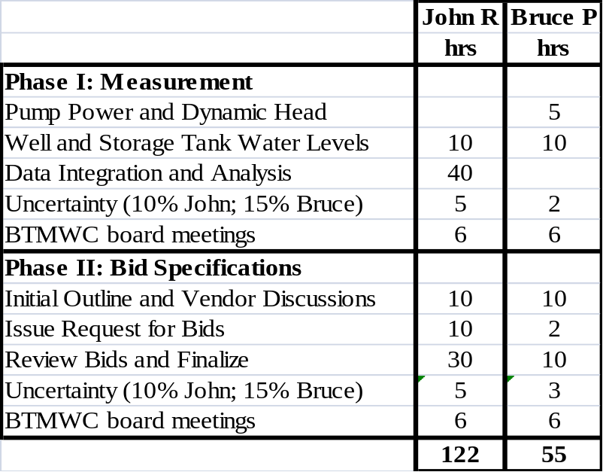

TABLE 2

